\*\*Casting TRUNCATES numbers (no rounding)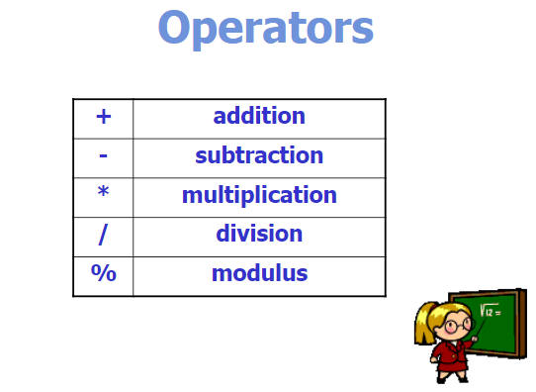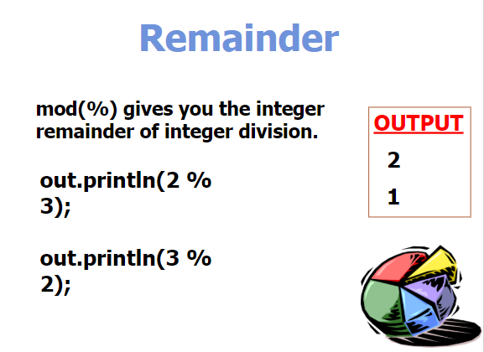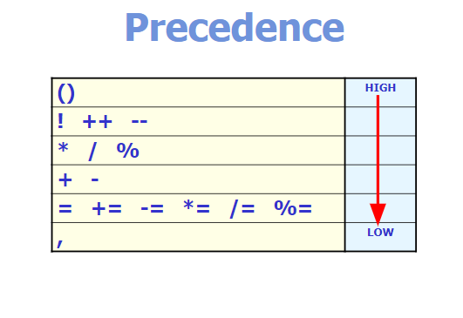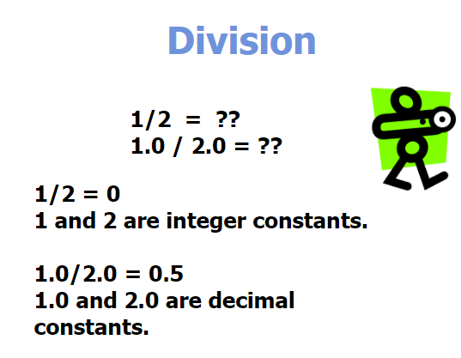

\*\* To use exponentiation use “Math.pow(number, power);” may have to CAST since it’s Math uses DOUBLES by default

\*\*Be careful when working with integer math (watchout for any fractions which would result in zero)